Question 1:

|  |  |
| --- | --- |
| **User Datagram Protocol** | **Transmission Control Protocols** |
| connectionless | establish a connection before sending a message |
| Streamlined and fast | slower |
| No flow control or congestion control | provides flow control and congestion control |
| unreliable | reliable |

They are both part of the transport layer of the OSI model

Question 2:

Layer 7: Application Layer - File Transfer Protocol

Layer 6: Presentation Layer - Lightweight Presentation Protocol

Layer 5: Session Layer - Remote Procedure Call Protocol

Layer 4: Transport Layer - Transmission Control Protocol

Layer 3: Network Layer - Internet Protocol

Layer 2: Data Link Layer - IP Control Protocol

Layer 1: Physical Layer - Ethernet cables

Question 3:

HTTPS is a secure version of HTTP that has encryption. The encryption protects users from attacks from compromised networks.

Question 4:

A port is a numerical value assigned to a specific process. A socket is a combination of port and IP address. The port number for email is 25.

Question 5:

By connecting to a public wifi network or using http you run the risk of cyber attacks, identity theft, or viruses.

Question 6:

My IPv4 address is 192.168.68.60

Question 7:

The Ping command is used to verify connectivity to an IP address. It transmits a packet and tells you how long it took.

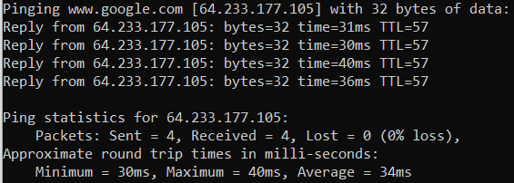

Question 8:

My router’s IP address is 192.168.68.1

2.4GHz & 5GHz

2 channels for 2.4GHz & 40 channels for 5GHz

My bandwidth is 158 Mbps

I can change my Wi-Fi password

I cannot change my email password

Question 9:

Status code 200 means the request was complete.

Status code 404 means the website could not be found.

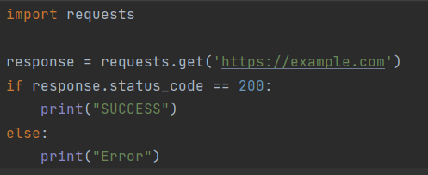

https://www.google.com

